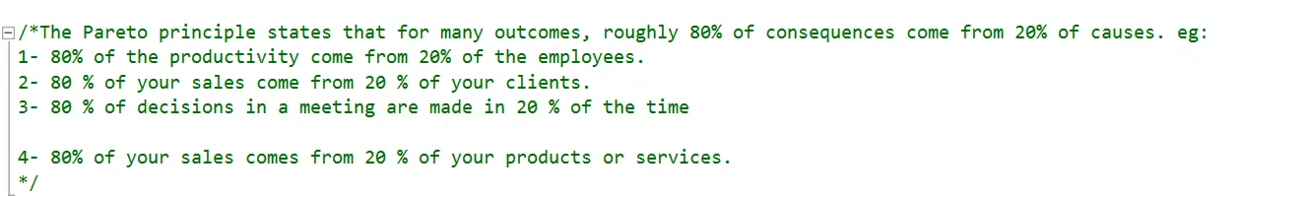  
  
This query is focused on Pareto Principle.